|  |  |  |  |
| --- | --- | --- | --- |
| **Name of Student: NINAD AVINASH PATIL** | | | |
| **Roll No: 33** | | **Lab Practical Number: 2(B).1** | |
| **Title of Lab Practical: Create a Windows form application where arraylist accepts 10 items. After loading 10 items use sort method to sort and search method to search an item.** | | | |
| **DOP: 03/03/2021** | | **DOS: 10/03/2021** | |
| **CO Mapped: CO1** | **PO Mapped: PO3, PO5, PO7,**  **PO12, PSO1, PSO2** | **Faculty Signature:** | **Marks:** |

**Practical No 2(B).1**

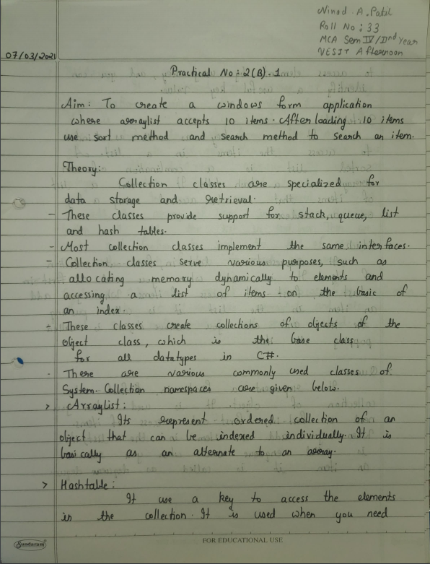

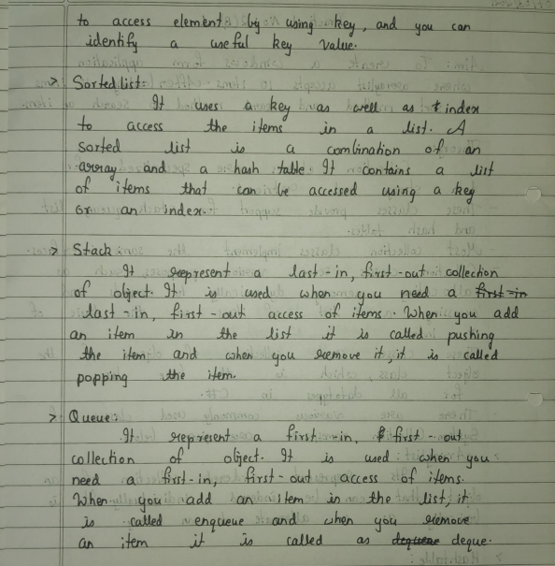

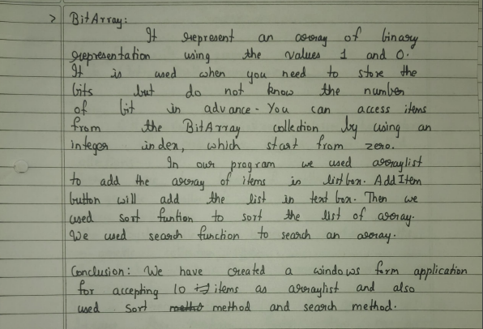

**Code:**

using System;

using System.Collections.Generic;

using System.ComponentModel;

using System.Data;

using System.Drawing;

using System.Linq;

using System.Text;

using System.Windows.Forms;

using System.Collections;

namespace WindowsFormsApplication3

{

public partial class Form1 : Form

{

ArrayList arr;

public Form1()

{

InitializeComponent();

textBox1.Visible = false;

}

private void button1_Click(object sender, EventArgs e)

{

arr = new ArrayList();

arr.Add("Hyundai");

arr.Add("Renualt");

arr.Add("Kia");

arr.Add("Toyata");

arr.Add("Maruti Suzuki");

arr.Add("Tata");

arr.Add("Honda");

arr.Add("Mahindra");

arr.Add("Audi");

arr.Add("BMW");

listBox1.DataSource = null;

listBox1.DataSource = arr;

}

private void button2_Click(object sender, EventArgs e)

{

textBox1.Visible = true;

int c = 0;

foreach (string a in listBox1.Items)

{

c++;

if (a == textBox1.Text) { MessageBox.Show(a + " found at index " + c); }

}

}

private void button3_Click(object sender, EventArgs e)

{

listBox1.DataSource = null;

arr.Sort();

listBox1.DataSource = arr;

}

private void button4_Click(object sender, EventArgs e)

{

textBox1.Visible = false;

listBox1.DataSource = null;

arr.Clear();

listBox1.DataSource = arr;

}

}

}

**Output:**

